**Homework – 3 ( Group 5)**

1. Tobit model Analysis

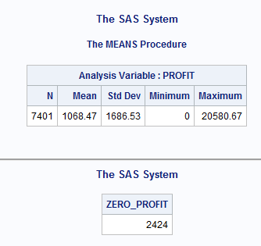

As almost one third of the data have profit as zero, we can say that the data is Censored data.

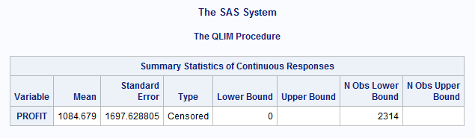

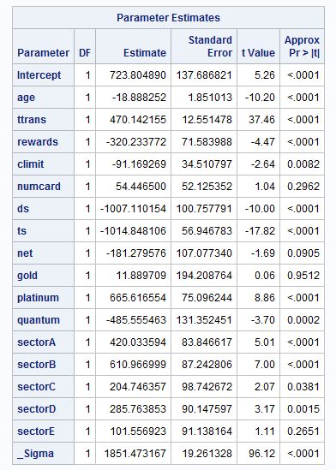

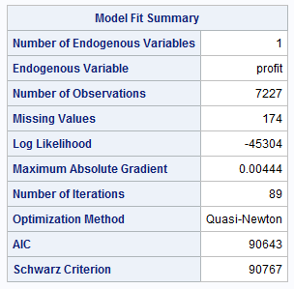

We have scaled totaltrans and limit variable by 10000.

**a. Interpretation**s:

Age- A year increase in person’s age decreases the profit by $18.89.

Tottrans – for every additional transaction of $10000 a person makes over a period of 3 year, the profit increases by $470.14

Rewards – Credit card company makes a profit of $320.23 from the customers who do not have rewards card as compared to the customers who have rewards card.

Limit -Every $10000 increase in the limit decreases the profit by $91.16

Numcard – This variable is insignificant at 95% of confidence interval

Modes of Acquisition

1. DM- We have kept Direct Mail as our reference group
2. DS – Profit from credit cards sold directly is $1007 less than that acquired through direct mail
3. TS – Profit from customers acquired through telephone selling is $1014 less than that acquired through direct mail
4. NET – This is insignificant at 95% of confidence interval but can be significant at 90% depicting that customers acquired through internet contributes to less profit.

Type of Card

1. Standard - We have kept standard card as our reference group.
2. Gold – This is insignificant at 95% confidence interval so we can say that there is not much difference in the profit made from the customer with Gold and Standard card.
3. Platinum – Profit from customers having platinum card is $665 more than those having standard card
4. Quantum - Profit from customers having quantum card is $485 less than those having standard card

Types of Affinity Cards

1. sectorF – Affinity card affiliated with Commercial is our reference group
2. SectorA - Cards not associated with affinity to any organization makes a profit of $420 more than the base group.
3. SectorB- Affinity card affiliated with Professional organization makes a profit of $610 more than the base group.
4. sectorC - Affinity card affiliated with Sports makes a profit of $204 more than the base group.
5. sectorD - Affinity card affiliated with Financial institution makes a profit of $285 more than the base group.
6. sectorE- Affinity card affiliated with University is not significant at 95% confidence interval and can be considered as making profit similar to Affinity card affiliated with Commercial

To get the model fit we will compare the AIC and SC with the model run without dummy variables

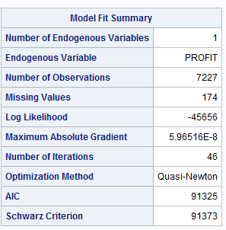

As AIC and SC penalizes the log likelihood for the number of predictors in the model, model with smallest AIC and SC is desired.

Comparing the AIC and SC score of this model with our original model tell that the original model fits better than the model without dummy variables

**b. Which mode of acquisition generates the highest profit?**

**-** As all other modes of acquisitions shows decrease in the profit when compared to the direct mail, we can say that the customers acquired though Direct mail generates the highest profit.

**c. Order the modes of acquisition from high to low in terms of profit.**

**-** Direct Mail > Internet > Direct Sales > Telephonic Sales

2. Selection Model Analysis:

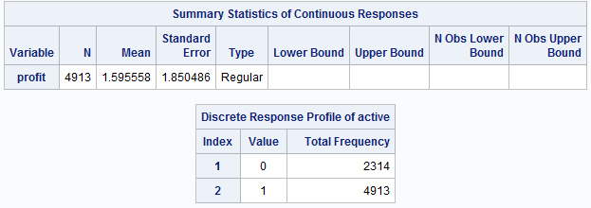To run the selection model on profit, we will first scale the profit by dividing it by 1000

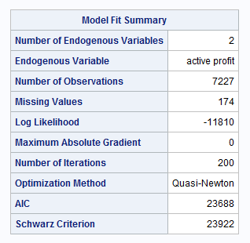

This shows that there are 4913 active users who have used their credit cards. Without selection model the profit would have tend to give biased values.

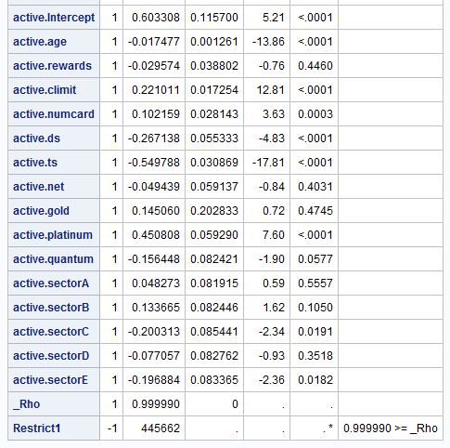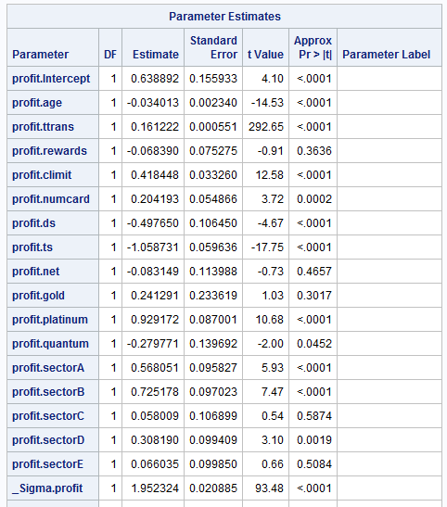

**a.** **Interpretation :**

As rho is almost equals to positive one we can say that there is selection bias in the given data.

While interpreting profit the significance and sign of almost all variables is same as that of Tobit model output except:

1. Rewards become insignificant for active users which means the profit is more is less similar for the users with or without rewards card if they are active.
2. sectorC i.e. Affinity card affiliated with Sports have similar profit as compared to the customers with affinity card affiliated with Commercial.

The changes in the activeness of the customer can be described as:

* The probability of a customer being active decreases by 0.017 with increase in their age
* Reward card does not play a significant role in the active status of a customer
* The probability of a customer being active increases by 0.22 with increase in their credit limit
* The probability of a customer being active increases by 0.102 with each extra card
* The probability of a customer being active is less for all the customers acquired through Direct sales and telephonic sales as compared to the customers acquired through Direct mail.
* Customers acquired through Internet sales behaves similar to the customer acquired through Direct mail.
* The probability of a customer being active with platinum card is more as compared to the customers with standard card
* The probability of a customer being active with Quantum card is less as compared to the customers with standard card
* The probability of customer being active is less for customers with Affinity card affiliated with Sports and University with less than 95% confidence interval

Model Fit:

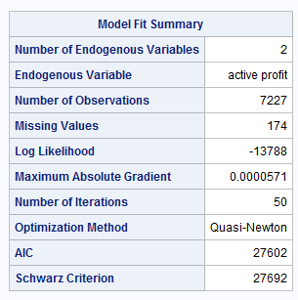

To get the model fit we will compare the AIC and SC with the model run without dummy variables

As AIC and SC penalizes the log likelihood for the number of predictors in the model, model with smallest AIC and SC is desired.

Comparing the AIC and SC score of this model with our original model tell that the original model fits better than the model without dummy variables

**b. Which type of affinity card generates the most profit? Order the types from best to worst in terms of profit.**

- Affinity card affiliated with Professional organization (sectorB) generates the most profit

In terms of profit order can be shown as below :

sectorB > sectorA > sectorD > sectorC ~ sectorE ~ sector

3. Survival Analysis

After deleting all inactive customers we are left with 4977 records where maximum of duration is 37 that means data is censored.

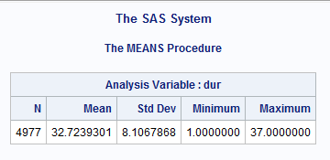

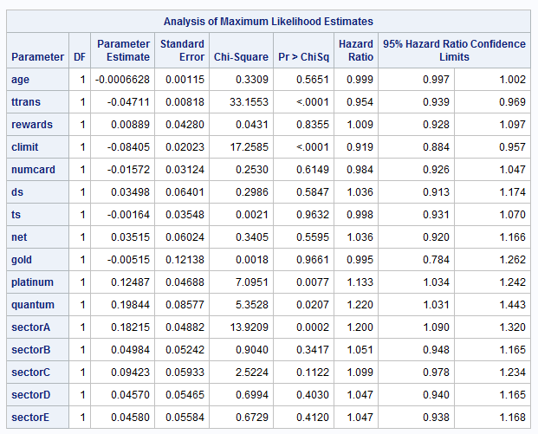

Interpretation :

There are no intercepts in the model as it is characteristics of partial likelihood.

For all the significant variables (pr<0.05) we can say that-

* As the total transaction amount increases by $1000 the probability that the customer will discontinue with the credit card firm decreases by 4.7%
* As the limit on the credit card increases by $1000 the probability that the customer will discontinue with the credit card firm decreases by 8.4 %
* The probability of Platinum card holder discontinuing is 13% more than the customers with standard card
* The probability of Quantum card holder discontinuing is 22% more than the customers with standard card
* The probability of customers with cards not affiliated to any organization is 20% more than the customer with the card affiliated with the commercial organization.

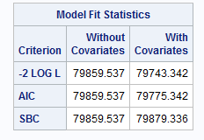As the test statistics for the model with covariates is less than the model without covariates we can say that our current model fits better.

**4.** Weibull distribution

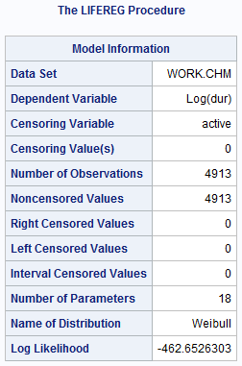 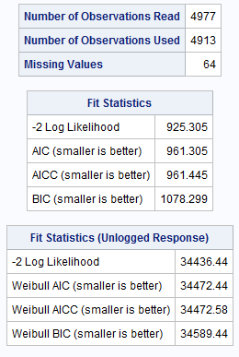

**Model Fit:**

The log likelihood of Weibull distribution is . The log likelihood value can be used to compare the goodness of fit for nested models with different covariates, but with the same distribuion.

The unlogged response fit statistics table is based on the maximum Weibull log likelihood using Duration as the response. The AIC, BIC and AICC statistics in this table can be used to compare models with different covariates and different distributions, as long as the fir statistics for the models that you compare use Duration as the response.

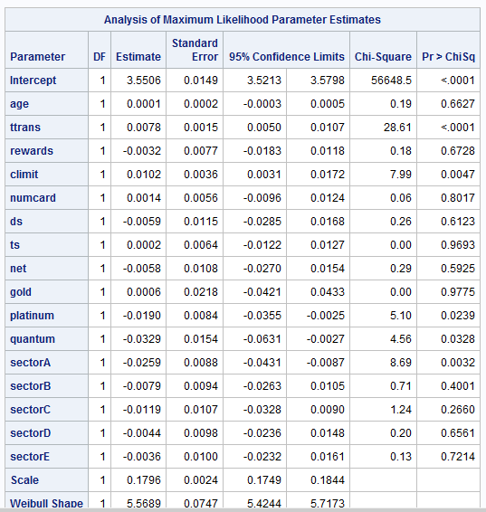

**Interpretation:**

Most of the variables from the model became insignificant with Weibull distribution. The significant variables can be interpreted as

* For every $10000 increase in the total transaction value by the customer, the duration for which he stays with the firm increases.
* Similarly, for every $10000 increase in the credit card limit for the customer, the duration for which he stays with the firm increases.
* There is not much difference in the duration of stay of standard and gold card holders, but platinum and quantum card holders leave the firm earlier by standard card holder.
* Having affinity card affiliated with commercial plays an important role in retaining the customer as compare to customer with no affinity card or other types of affinity card.

SAS Codes:

**data** ctm;

set input.CC10;

profit = (totfc\***1**) + (**0.016**\*tottrans);

tottrans = tottrans/**1000**;

limit=limit/**1000**;

**run**;

/* Q1 Tobit Model Analysis */

**proc** **qlim** data=ctm;

model profit = age tottrans rewards limit numcard ds ts net gold platinum quantum sectorA sectorB sectorC sectorD sectorE;

endogenous profit ~ censored (lb=**0**);

**run**;

**proc** **qlim** data=ctm;

model profit = age tottrans rewards limit numcard;

endogenous profit ~ censored (lb=**0**);

**run**;

/* Q2 Selection Model Analysis */

**data** csm;

set ctm;

if tottrans = **0** then active = **0**;

else if tottrans > **0** then active = **1**;

**run**;

**data** csm1;

set csm;

profit = profit/**1000**;

**run**;

**proc** **qlim** data=csm1;

model active = age rewards limit numcard /discrete;

model profit = age tottrans rewards limit numcard / select(active=**1**);

**run**;

/* Q3 Survival Analysis */

**data** chm;

set csm;

if active = '0' then delete;

**run**;

**proc** **print** data=chm (obs=**2**);

**run**;

**PROC** **MEANS** DATA=chm;

VAR dur;

**RUN**;

**proc** **univariate** data = chm;

var dur;

**run**;

**proc** **phreg** data=chm;

model dur*active(**0**) = age tottrans rewards limit numcard ds ts net gold platinum quantum sectorA sectorB sectorC sectorD sectorE /RL;

**run**;

/* Q4 Weibull Distribution */

**proc** **lifereg** data=chm;

model dur*active(**0**) = age ttrans rewards climit numcard ds ts net gold platinum quantum sectorA sectorB sectorC sectorD sectorE/ dist=weibull;

**run**;